URL

<https://www.allaboutcircuits.com/projects/flashing-the-ESP-01-firmware-to-SDK-v2.0.0-is-easier-now/>

1. esp8266 ESP-01 Must be in flash Mode

|  |  |  |
| --- | --- | --- |
| esp8266 | Arduino | Power Supply |
| RX | RX |  |
| TX | TX |  |
| VCC & CH_PD |  | 3.3 V |
| GND & PGIO0 | GND | GND |

1. – download Bins file from URL (this Espressif AT Commands Firmware)

<https://www.espressif.com/en/support/download/sdks-demos>



3 – Use ESPFlashDownloadTool_v3.6.4 tool to flash bins file like image

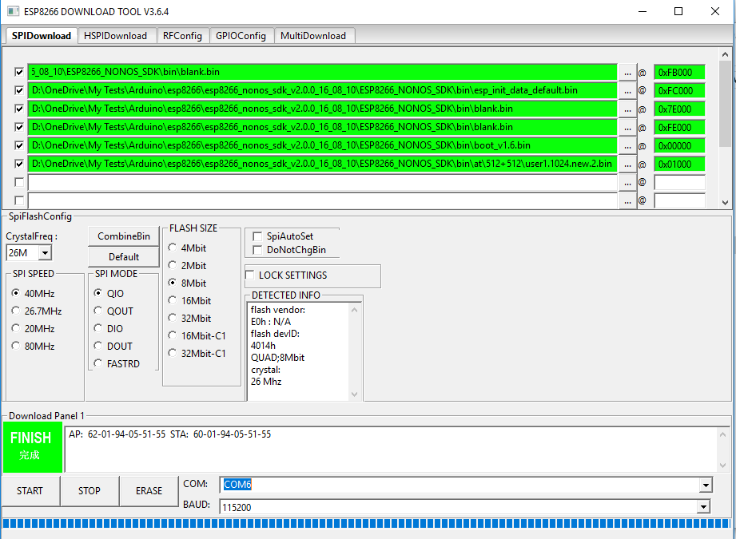

To test with Arduino IDE Serial monitor

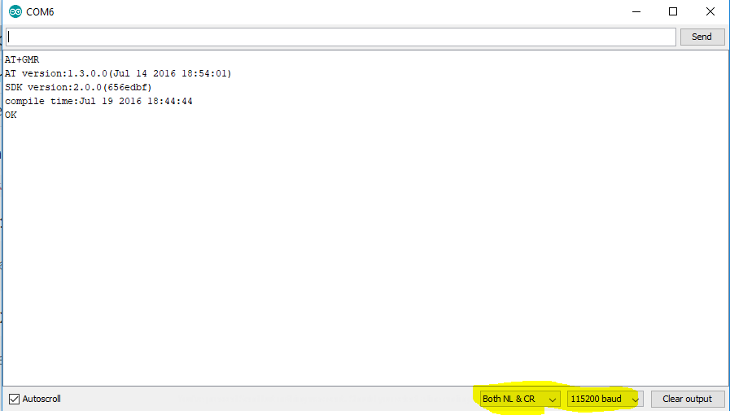

# To use Ai Thinker Firmware

# 